EXPERIMENT 10

TRIGGERS

**Aim:**

1. Create a table with attribute sname, and another table with newname.
2. Create a trigger to insert into second table before inserting in first table.
3. Create a table for account details with attributes account number and an amount.
4. Create a trigger to check if amount is negative or greater than zero before inserting to table.

1.



2.

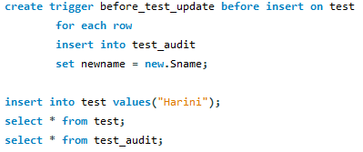

 

3.



4.

